Bangladesh Medical Association (BMA)
List of Life Member-68
46. BMA Natore Branch

Sl No | Voter No | Voter Details
1 | Voter No  LM-4600001  No Image | DR. MD. ABDUL MASUD  F/Name:  M/Name:  BM & DC Reg. No:  NID:  Cell:  Address: Senior Consultant  Sadar Hospital  Natore  Blood Group:
2 | Voter No  LM-4600002  No Image | DR. ALAMGIR KABIR  F/Name: M. Enttaj Ali  M/Name:  BM & DC Reg. No:  NID:  Cell:  Address: Rafiq Villa. Mallikhati  Natore  Blood Group:
3 | Voter No  LM-4600003  No Image | DR. SAMAR KUMAR GHOSH  F/Name:  M/Name:  BM & DC Reg. No:  NID:  Cell:  Address: TRANSFERED to BMA Dhaka City  LM-2355  Blood Group:  TRANSFERED to BMA Dhaka City  LM-1405543
4 | Voter No  LM-4600004  No Image | DR. MD. RAZIQUL AHSAN  F/Name:  M/Name:  BM & DC Reg. No:  NID:  Cell:  Address: Transfered to Bogra LM-146  Blood Group:  TRANSFERED to BMA Dhaka City  LM-1405543
5 | Voter No  LM-4600005  No Image | DR. ABDUL AHAD  F/Name: Late Jaharullah PK  M/Name:  BM & DC Reg. No:  NID:  Cell:  Address: TH & FPO  Singra  Natore  Blood Group:
6 | Voter No  LM-4600006  No Image | DR. MD. SAKHAWAT HOSSAIN  F/Name: Late Akher Uddin  M/Name:  BM & DC Reg. No:  NID:  Cell:  Address: Thana Health Complex  Bagatipara  Natore  Blood Group:
7 | Voter No  LM-4600007  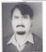 | DR. MUHAMMAD MOTIUR RAHMAN  F/Name: Mr. Raisuddin Ahmed  M/Name:  BM & DC Reg. No:  NID:  Cell:  Address: Consultant Medicine  Sadar Hospital  Natore  Blood Group:
8 | Voter No  LM-4600008  No Image | DR. MD. MOHSIN ALI  F/Name: Late Insan Ali Malita  M/Name:  BM & DC Reg. No:  NID:  Cell:  Address: Medical Officer  Civil Surgeon Office  Natore  Blood Group:
9 | Voter No  LM-4600009  No Image | DR. RASHIDA KHATUN  F/Name: Late Masir Uddin Miah  M/Name:  BM & DC Reg. No:  NID:  Cell:  Address: Medical Officer  TB Clinic  Natore  Blood Group:
10 | Voter No  LM-4600010  No Image | DR. SHAH AMANULLAH CHOUDHURY  F/Name:  M/Name:  BM & DC Reg. No:  NID:  Cell:  Address: TRANSFERED to BMA Rajshahi Branch  LM-  Blood Group:  TRANSFERED to BMA Dhaka City  LM-1405543
11 | Voter No  LM-4600011  No Image | DR. MD. ASAD UZ-ZAMAN MUNSHI  F/Name:  M/Name:  BM & DC Reg. No: 22395  NID:  Cell:  Address: Natore  Blood Group:  TRANSFERED to BMA Dhaka City  LM-1405543
12 | Voter No  LM-4600012  No Image | DR. MD. FAZLUR RAHMAN SHAIKH  F/Name: Md. Amiz Uddin Shaikh  M/Name:  BM & DC Reg. No:  NID:  Cell:  Address: RMO  Singra Thana Health Complex  Natore  Blood Group:
13 | Voter No  LM-4600013  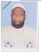 | DR. MD. AMIN UDDIN MIAH  F/Name: Md. Felue Pramanik  M/Name:  BM & DC Reg. No:  NID:  Cell:  Address: Medical Officer  Thana Health Complex, Singra  Natore  Blood Group:
14 | Voter No  LM-4600014  No Image | DR. SHAHELA ZESMIN  F/Name:  M/Name:  BM & DC Reg. No:  NID:  Cell:  Address: TRANSFERED to BMA Rajshahi Branch  LM-5500084  Blood Group:  TRANSFERED to BMA Dhaka City  LM-1405543
15 | Voter No  LM-4600015 | DR. A.H.M AMIRUL ISLAM  F/Name: Md. Hasan Ali  M/Name:  BM & DC Reg. No:  NID:  Cell:  Address: Medical Officer  Civil Surgeon Office  Natore  Blood Group:
16 | Voter No  LM-4600016  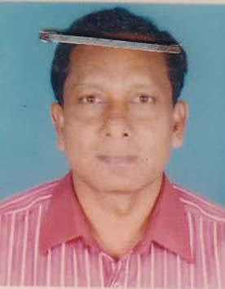 | DR. MD. MAZEDUL ISLAM  F/Name: Late Akbar Ali  M/Name: Late Zohura Begum  BM & DC Reg. No: 23107  NID: 6926303350723  Cell: 01713724143  Address: Akota Clinic Harishpur, Natore.  Blood Group: O+
17 | Voter No  LM-4600017 | DR. MD. ANSARUL HAQUE  F/Name: Md. Hazrat Ullah Sarkar  M/Name: Mrs. Amena Khatun  BM & DC Reg. No: 15811  NID: 6921508232718  Cell: 01713722419  Address: M.O(MCH-FR), Gurudash Pur, Natore.  Blood Group: A+
18 | Voter No  LM-4600018  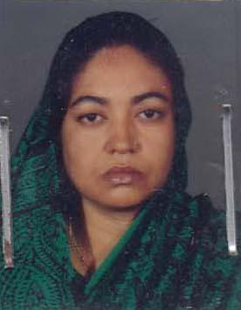 | DR. B.N.A FERDAUS MAHAL ABDASSY  F/Name: Late Mohd. Nazibur Rahman Abdassy  M/Name: Rezia Begum  BM & DC Reg. No: 11207  NID: 6926303353224  Cell: 01715002034  Address: Niramoy Pharmacy Hospital Road, Natore.  Blood Group: B+
19 | Voter No  LM-4600019  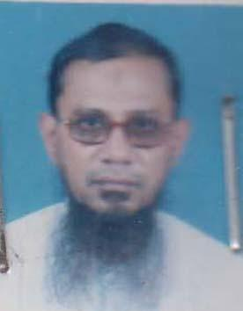 | DR. MUHSINUL BARI MUHAMMAD ISHTIAQUE  F/Name: Late Mohd. Isharat Ali  M/Name: Late Rezia Begum  BM & DC Reg. No: 10451  NID: 6926303353242  Cell: 01715945747  Address: Niramoy Pharmacy Hospital Road, Natore.  Blood Group: O+
20 | Voter No  LM-4600020 | DR. MD. BELAL HOSSAIN  F/Name: Late Tamiz Uddin Pramanik  M/Name: Saleha Begum  BM & DC Reg. No: 16498  NID: 6926306368952  Cell: 01711894740  Address: Radiologist Adhunik Sadar Hospital, Natore.  Blood Group: A+
21 | Voter No  LM-4600021  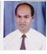 | DR. SM ZAKIR HOSSAIN  F/Name: Mohammad Ali  M/Name:  BM & DC Reg. No:  NID:  Cell:  Address: Akota Clinic  Natore.  Blood Group:
22 | Voter No  LM-4600022  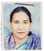 | DR. NAZMUN NAHAR  F/Name: Md. Nurul Haque  M/Name:  BM & DC Reg. No:  NID:  Cell:  Address: 123/2 BOLARIPARA  Natore.  Blood Group:
23 | Voter No  LM-4600023 | DR. MD. SAIDUR RAHMAN  F/Name: Late Hazi Eunusur Rahman  M/Name:  BM & DC Reg. No:  NID:  Cell:  Address: Akota Clinic  Natore  Blood Group:
24 | Voter No  LM-4600024  No Image | DR. MD. ASAD-UZ-ZAMAN MUNSHI (TONY)  F/Name:  M/Name:  BM & DC Reg. No:  NID:  Cell:  Address: : Late Golam Nabi Munshi  Blood Group:  TRANSFERED to BMA Dhaka City  LM-1405543
25 | Voter No  LM-4600025  No Image | DR. MD. ABDUS SATTAR  F/Name: Late Alhaj Md. Hurmatullah  M/Name:  BM & DC Reg. No: 8817  NID:  Cell:  Address: Natore  Blood Group:
26 | Voter No  LM-4600026  No Image | DR. MD. MANSUR ELAHI  F/Name: Md. Mahboob Elahi  M/Name:  BM & DC Reg. No:  NID:  Cell:  Address: Upazila Health Complex,  Bagatipara Upazila.  Natore.  Blood Group:
27 | Voter No  LM-4600027 | DR. MD. ABDUL GHANI  F/Name: Late Abu Moslem Mondal  M/Name: Golap Jan Begum  BM & DC Reg. No: 16135  NID: 6926304359897  Cell: 01716019599  Address: RMO, Adunic Sadar Hospital, Natore.  Blood Group: B+
28 | Voter No  LM-4600028  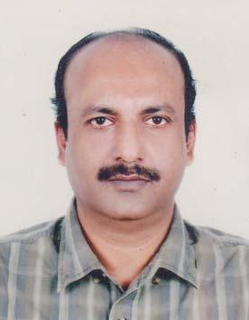 | DR. MD ZAKIR HOSSAIN TALUKDER  F/Name: Md. Jahir Uddin Talukder  M/Name: Rokeya Begum  BM & DC Reg. No: 21299  NID: 6926306368309  Cell: 01711574862  Address: Soma Pathology, Kanaikhali, Natore-6400.  Blood Group:
29 | Voter No  LM-4600029 | DR. SHANTONU KUMAR GHOSH  F/Name: Late Dr. Ashim Kumar Ghosh  M/Name: Mukti Ghosh  BM & DC Reg. No: 31006  NID: 6926306372686  Cell: 01715405567  Address: Resident Cardiovascular & Thoracic Surgery, Bangabandhu Sheikh Mujib Medical University, Dhaka.  Blood Group: A+
30 | Voter No  LM-4600030 | DR. SAMIRAN KUMAR KUNDU  F/Name: Late Ram Chandra Kundu  M/Name: Gita Rani Kundu  BM & DC Reg. No: 21457  NID: 19676926302347052  Cell: 01712151516  Address: Alaipur, Natore Sadar, Natore.  Blood Group: B+
31 | Voter No  LM-4600031  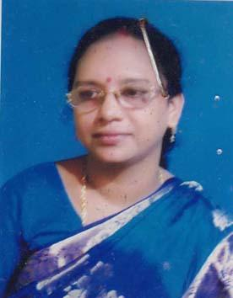 | DR. SAMPA RANI KUNDU  F/Name: Ram Chandra Kundu  M/Name: Aloka Rani Kundu  BM & DC Reg. No: 21622  NID: 19676926302347054  Cell: 01711705374  Address: Alaipur, Natore Sador, Natore.  Blood Group: B+
32 | Voter No  LM-4600032 | DR. A.S.M. FERDOUS  F/Name: Alhaz Delwar Hossain  M/Name: Prof. Rokeya Begum  BM & DC Reg. No: 50807  NID: 2692984611061  Cell: 01711363812  Address: 16/2, Borovita, Natore, Dist: Natore.  Blood Group: O+
33 | Voter No  LM-4600033 | DR. KHR MD. SHAHJAHAN ALI  F/Name: Late Hossain Uddin Khblaker  M/Name: Late Amena  BM & DC Reg. No: 15812  NID:  Cell:  Address: Boro Horispur Natore Consultant Ortho Sador Hospital, Natore  Blood Group:
34 | Voter No  LM-4600034  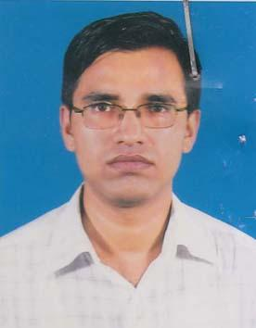 | DR. MD. SHAHIDUL HAQUE  F/Name: Late Abdul Aziz  M/Name: Most. Mahbuba Aziz  BM & DC Reg. No: 37929  NID: 19808198506000009  Cell: 01911515054  Address: M.O. Adhunik Sadar Hospital, Natore.  Blood Group: O+
35 | Voter No  LM-4600035 | DR. TULSHI CHANDRA ROY  F/Name:  M/Name:  BM & DC Reg. No: 23103  NID: 6926305366362  Cell: 01741388018  Address: MO. Sador Hospital, Natore.  Blood Group: B+  TRANSFERED to BMA Dhaka City  LM-1405543
36 | Voter No  LM-4600036  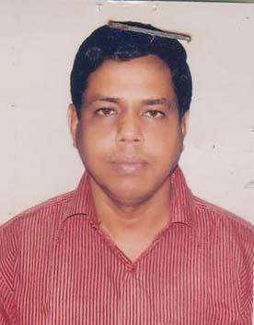 | DR. PANKAJ KUMAR SARKER  F/Name: Siddheswar Sarker  M/Name: Gita Sarkar  BM & DC Reg. No: 15921  NID: 8192223140771  Cell: 01717215279  Address: Junior Consultant ( Anaesthesia) Adunik Sadar Hospital, Natore.  Blood Group: O+
37 | Voter No  LM-4600037 | DR. MD. ABUL KALAM AZAD  F/Name: Late Abul Kashem  M/Name: Habiba Begum  BM & DC Reg. No: 44764  NID: 6926305365785  Cell: 01711819677  Address: Medical Officer, Rani Brozo Sundori USC, Sadar, Natore.  Blood Group: O+
38 | Voter No  LM-4600038 | DR. MD. TAIMUR RAHMAN  F/Name: Md. Akimuddin Pk  M/Name: Mrs. Tohomina Khatun  BM & DC Reg. No: 32770  NID: 2691650154855  Cell: 01711040809  Address: MO Adhunik Sadar Hospital, Natore.  Blood Group: B+
39 | Voter No  LM-4600039 | DR. MD. ABDUL HAMID MIAH  F/Name: Dr. Ali Ahmed  M/Name: Suraton Nesa  BM & DC Reg. No: 13205  NID: 6926304361564  Cell: 01711006599  Address: Kanaikhali, Natore.  Blood Group:
40 | Voter No  LM-4600040  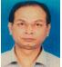 | DR. MD ABUL ASAD  F/Name: Late Md Abul Hossain  M/Name: Mrs Latifa Begum  BM & DC Reg. No: A 30397  NID:  Cell:  Address: Chakrampur,  Natore  Blood Group:
41 | Voter No  LM-4600041  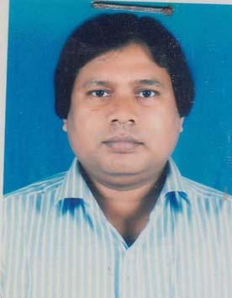 | DR. ABDUS SAMAD  F/Name: Md. Paran Uddin Pk  M/Name: Mrs Hawa Begum  BM & DC Reg. No: 25524  NID: 6926303351403  Cell: 01712090890  Address: Ideal Diagnostic Centre Natore.  Blood Group: O+
42 | Voter No  LM-4600042 | DR. ABDULLAH YAHIA KHAN  F/Name: Late Rustom Ali Khan  M/Name: Late Khadiza Khanom  BM & DC Reg. No: 33072  NID: 6926304357295  Cell: 01711284146  Address: Ibrahim Diabetic Centre, Natore, Madrasa More, Natore, Dist-Natore  Blood Group: AB+
43 | Voter No  LM-4600043  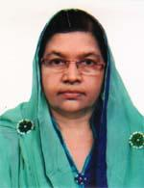 | DR. FAIZUN NESA  F/Name: Late Md. Hossain Ali  M/Name: Late Mst. Razia Begum  BM & DC Reg. No: 31424  NID: 6926304357297  Cell: 01716147475  Address: Ibrahim Diabetic Centre, Natore, Madrasa More, Natore, Dist-Natore  Blood Group: B+
44 | Voter No  LM-4600044  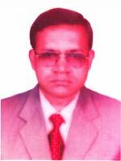 | DR. MD. ABDUS SAMAD  F/Name:  M/Name:  BM & DC Reg. No: 23526  NID: 8192219324389  Cell: 01711302274  Address: Ibrahim Diabetic Centre Natore, Madrasa More , Natore, Dist-Natore  Blood Group: A+  TRANSFERED to BMA Dhaka City  LM-1405543
45 | Voter No  LM-4600045 | DR. MD. OBAYDUL HAQUE  F/Name: Late Hazrat Ali  M/Name: Bilkish Begum  BM & DC Reg. No: 16564  NID: 8194028195683  Cell: 01712053707  Address: Vill-Patuapara (madrasamore) Upazilla-Natore, Dist-Natore  Blood Group: AB+
46 | Voter No  LM-4600046 | DR. MD. ABDUL MANNAN  F/Name: Late Abdul Khaleque  M/Name: Late Meherun Nessa  BM & DC Reg. No: 16517  NID: 6926304361470  Cell: 01711894743  Address: Somota Complex Bhaban, Balari Para, Natore  Blood Group: O+
47 | Voter No  LM-4600047  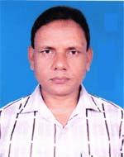 | DR. ABDUR ROUF MALLIK  F/Name: Abdul Quddus Mallik  M/Name: Rejea Begum  BM & DC Reg. No: 21843  NID: 6926303352731  Cell: 01712754532  Address: Upazilla Health Complex, Singra, Natore  Blood Group: A+
48 | Voter No  LM-4600048 | DR. AKLIMA KHATOON  F/Name: Md. Aminul Haque  M/Name: Marium Begum  BM & DC Reg. No: 28982  NID: 6926303352732  Cell: 01715205068  Address: Health Complex, Singra, Natore  Blood Group: A+
49 | Voter No  LM-4600049 | DR. MD. MURAD HOSSAIN  F/Name: Md. Mokbul Hossain  M/Name: Bilkis Akter Banu  BM & DC Reg. No: 56805  NID: 6929104917229  Cell: 01718011128  Address: Upazilla Health Complex, Singra, Natore  Blood Group: A+
50 | Voter No  LM-4600050 | DR. MD. NAZMUL HOSSAIN (TUHIN)  F/Name: Late. Md. Abdus Sukur Sarker  M/Name: Mst. Shahara Bibi  BM & DC Reg. No: A44850  NID: 6919115889753  Cell:  Address: Kanai Khali, Natore.  Blood Group: O+
51 | Voter No  LM-4600051  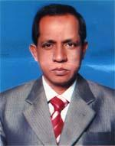 | DR. MD. YEADUL ISLAM  F/Name: Late Hazi Basharat Ullah P.k.  M/Name: Late Afejan Bewa  BM & DC Reg. No: 19225  NID: 6926306368821  Cell: 01711900668  Address: 416/01, Islam Cottage, Ward No.-6, Road No.-3, Alaipur, Natore  Blood Group: O+
52 | Voter No  LM-4600052 | DR. GOLAM MOHAMMAD NASER  F/Name: Mansur Uddin Ahmed  M/Name: Begum Momotaz Ahmed  BM & DC Reg. No: 23975  NID: 6926309385956  Cell: 01855931535  Address: CARE MEDICAL CENTRE, WEST BYPASS, BONBELGHORSA, NATORE  Blood Group: A+
53 | Voter No  LM-4600053 | DR. HABIBUN NABI MD. SHAFIQUZZAMAN  F/Name: Md. Abdul Jalil  M/Name: Fazilatun Nessa  BM & DC Reg. No: 32393  NID: 6914495512169  Cell: 01711950271  Address: Bolaripara, Borohorishpur, Natore Sadar, Natore  Blood Group: B+
54 | Voter No  LM-4600054  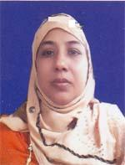 | DR. SALMA AKHTER  F/Name: Sk. Siddiqure Rahman  M/Name: Aleya Begum  BM & DC Reg. No: 33590  NID: 6914495512168  Cell: 01712986539  Address: Bolaripara, Borohorishpur, Natore Sadar, Natore  Blood Group: AB+
55 | Voter No  LM-4600055  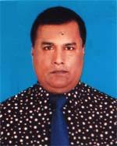 | DR. MD. EMDADUR RAHMAN  F/Name: Md. Nabi Hossain Miah  M/Name: Mrs. Aysha Nabi  BM & DC Reg. No: 23214  NID: 6926306367522  Cell: 01711124181  Address: Darul Makam, Mirpara, Natore Sadar, Natore  Blood Group: B+
56 | Voter No  LM-4600056  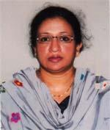 | DR. KAMRUN NAHAR  F/Name: Jainal Abedin  M/Name: Meherun Nessa  BM & DC Reg. No: 23873  NID: 6926309385957  Cell: 01855931534  Address: Care Medical Centre, West-Bypass, Bonbelgoria, Natore  Blood Group: O+
57 | Voter No  LM-4600057 | DR. MD. JAHEDUL ISLAM  F/Name: Md. Korban Ali  M/Name: Most. Jaheda Khatun  BM & DC Reg. No: 44093  NID: 6911583171600  Cell: 01796121771  Address: Adhunik Sadar Hospital, Natore  Blood Group: O+
58 | Voter No  LM-4600058  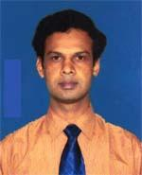 | DR. MD. HAFIZUR RAHMAN  F/Name: Late Abdus Samad Khan  M/Name: Late Rahela Begum  BM & DC Reg. No: 49789  NID: 6921503593758  Cell: 01733260100  Address: Vill-Ahmedpur, Post-Ahmedpur, P.s-Boraigram, Dist-Natore  Blood Group: AB+
59 | Voter No  LM-4600059  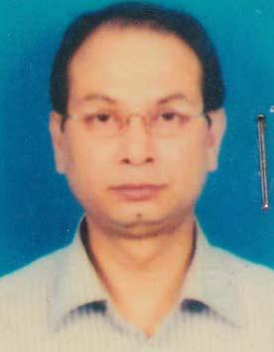 | DR. MD. ABUL ASAD  F/Name: Abul Hossain  M/Name: Ms. Latifa Begum  BM & DC Reg. No: 30397  NID: 6926303351093  Cell: 01716155688  Address: Vill-Chalkrampur, Post-Natore, P.s-Natore, Dist-Natore-6400  Blood Group: AB+
60 | Voter No  LM-4600060  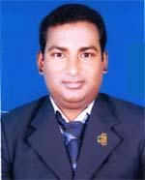 | DR. RONI AHMED  F/Name: Late Giash Uddin Ahmed  M/Name: Rezia Khatun  BM & DC Reg. No: 42621  NID: 6919123875348  Cell: 01716731777  Address: Vill-Khidra Baria, Post-Baria, Thana-Singra, Dist-Natore  Blood Group: B+
61 | Voter No  LM-4600061 | DR. MD. ABU BAKAR SIDDIQUE  F/Name: Md. Abdul Mannan Pradhamia  M/Name: Mrs. Shahana Mannan  BM & DC Reg. No: 68172  NID: 819220925164  Cell: 01752003710  Address: House No.-123/A, Bolari Para, Post+P.s-Natore Sadar, Dist-Natore  Blood Group: B+
62 | Voter No  LM-4600062 | DR. IMRAN KHAN  F/Name: Abdullah Yahia Khan  M/Name: Mst. Faizun Nesa  BM & DC Reg. No: 68219  NID: 6926304356420  Cell: 01713115458  Address: Ibrahim Diabetic Centre, Natore, Madrasa More, Natore, Dist-Natore  Blood Group: B+
63 | Voter No  LM-4600063 | DR. AYSHA SIDDIKA  F/Name: Raja Harun-ur-rashid  M/Name: Safinatul Kobra  BM & DC Reg. No: 74276  NID: 0695117222610  Cell: 01752082244  Address: Ibrahim Diabetic Centre Natore, Madrasa More, Natore, Dist-Natore  Blood Group: O+
64 | Voter No  LM-4600064 | DR. MD SIDDIQUR RAHMAN PATWARY  F/Name: Md. Younus Ali Patwary  M/Name: Ronyon Vanu  BM & DC Reg. No: A16483  NID: 6921503593760  Cell:  Address: House No-30, Vill-Bonpara  Basar, Boraigram, Bonpara, Natore.  Blood Group: O+
65 | Voter No  LM-4600065 | DR. HOSNE ARA HOSSAIN  F/Name: Md. Mokhter Hossain  M/Name: Manowara Begum  BM & DC Reg. No: A19664  NID: 6921503593761  Cell:  Address: House No-30, Vill-Bonpara Basar  Boraigram, Bonpara, Natore.  Blood Group: O+
66 | Voter No  LM-4600066 | DR. RANJAN KUMAR DATTO  F/Name: Probodh Kumar Datto  M/Name: Sorosoti Datto  BM & DC Reg. No: 16776  NID: 6921509233686  Cell: 01711480448  Address: H/No.-270/01 Kaliuapur, Haroa Baraigram, Natore  Blood Group: A+
67 | Voter No  LM-4600067 | DR. MD. MASUD RANA SARKER  F/Name: Late. Yousuf Ali Sarker  M/Name: Mst. Monoara Begum  BM & DC Reg. No: 47872  NID:  Cell:  Address: Medical Officer, Adhunik Sadar Hospital, Natore.  Blood Group:
68 | Voter No  LM-4600068  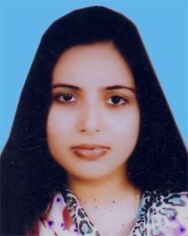 | DR. SUKANYA SARKER  F/Name: Sudip Kumar Sarker  M/Name: Dolly Adhikary  BM & DC Reg. No: 78820  NID: 1991692630100011  Cell: 01706-060707  Address: Address: 34, Upper Bazar, Natore Natore Sadar, Natore.  Blood Group: AB+

